Theme
https://themeforest.net/item/industry-factory-industrial-business-template/18923314?_ga=2.49651878.1846377405.1512332752-2002611899.1512332752

Important for choice:
The template Industry - Factory & Industrial Business serves as an example for me and may also be bought which will be paid. It is important that the site is well built up, works quickly and unnecessary code is removed.http://kodesolution.com/demo/wxyz/y/industrypress/v2.0/demo/index-boxed-mp-layout5.html
so if you feel that this theme can be omitted, it is good too.

We have decided that it is a WordPress site.
The Tim themes can be used, however I would like to change the wizard to the example
http://rvs-keukenblad.nl/rvskeukenblad-offerte.php?type=12
When the ste is finished, I will inform you how the other wizard should be placed.

Design and functionality
HOME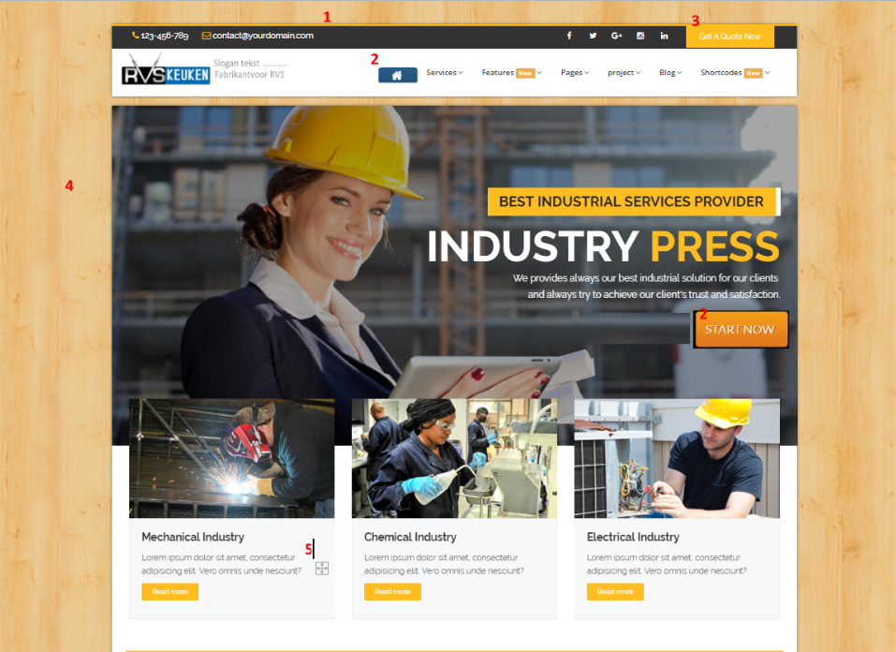

upper bar, color blue as homehosing.nl NUMBER 1
Idem button 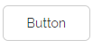, same as start now little radius. NUMBER 2
4)Please layout Box, that means with background stainless steel. Same as www.homehositng.nl
a slogan text next to the logo

The 3 blocks as shown. Layout2
http://kodesolution.com/demo/wxyz/y/industrypress/v2.0/demo/index-mp-layout2.html

tabs
http://kodesolution.com/demo/wxyz/y/industrypress/v2.0/demo/shortcode-tabs.html

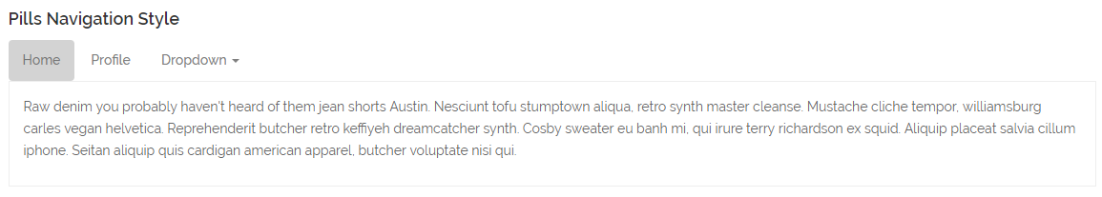

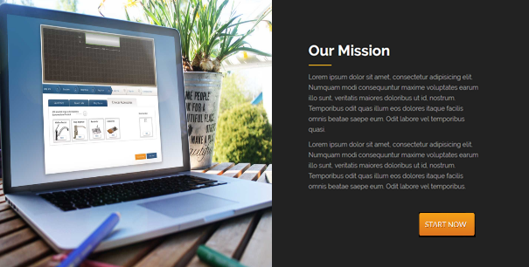

intermediate block
Like the black surface in design and a suitable color.
Gray of something els

Then on the home

Owl Carousel - 3 Columns:
http://kodesolution.com/demo/wxyz/y/industrypress/v2.0/demo/shortcode-owl-carousel.html
adjust the background to design
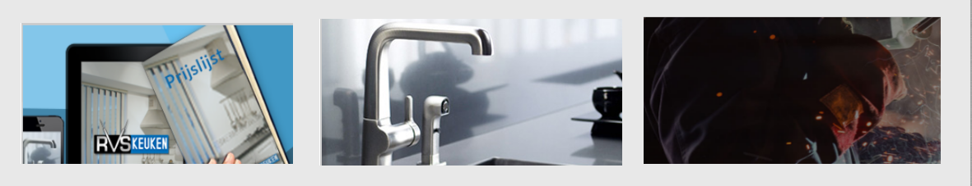

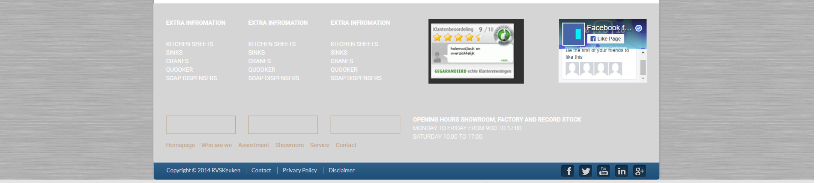
I also have the lower blue bar as above to return the style

the brands may be canceled at this site

